**Тестування API. JSON. REST.**

**Рівень 1**

**TC1:**

Selecting auto brands in the filter

Steps:

1 Visit https://automoto.ua/uk/car

2 Select "Універсал"

3 Under the brand select "Toyota" and check the results

ER: The filter applied and displays only Toyota - universal cars

Status: Passed

—-

**TC2:**

Testing the price range filter

Steps:

1 Visit https://automoto.ua/uk/car

2 Select "Універсал"

3 Under the brand select "Volkswagen"

4 Set the price from $4000 to $5000

5 Check the results

ER: The system filters the list according to the specified filter parameters

Status: Passed

—

**TC3:**

Checking the color filter

Steps:

1 Visit https://automoto.ua/uk/car

2 Select "Універсал"

3 Under the brand select "Volkswagen"

4 Select only the white color

5 Check the results

ER: The system filters the list and displays only 1 white passat

Status: Passed

**TC4:**

Checking the language selector

Steps:

1 Visit https://automoto.ua/uk/car

2 In the top right corner of the header find the language selector and press RU

3 After the page is loaded scroll down the page and ensure the filters, buttons and titles are translated

ER: The site is fully translated from UA to RU

Status: Passed

—

**TC5:**

Ensure the links in "Вживані авто" dropdown menu are valid

Steps:

1 Visit https://automoto.ua/uk/car

2 Hover your mouse over the dropdown menu "Вживані авто"

3 One by one hover the mouse over the available subpoints

4 Pay attention to the links displayed by the browser in the left bottom corner

5 Using the mouse wheel click all 3 menu buttons to open them in a separate tab

6 Switch to newly opened tabs and check if there are any errors

ER: The user should be able to see 3 newly opened pages in different tabs.

The following pages should appear:

https://automoto.ua/uk/car

https://automoto.ua/uk/moto

https://automoto.ua/uk/spectehnika

Status: Passed

**Рівень 2**

**Bug 1**

**Title:**

Using the POST API new user was created using only numbers in the name

**STR:**

1 Enter the following endpoint https://reqres.in/api/users

2 Select POST method

3 Enter the following content body:

{

"name": "1",

"job": "leader",

"id": "700",

"createdAt": "2023-02-26T14:49:46.093Z"

}

4 Press Send and check the results

AR: the system creates new user with the name "1";

ER: The name can't be created using only numbers

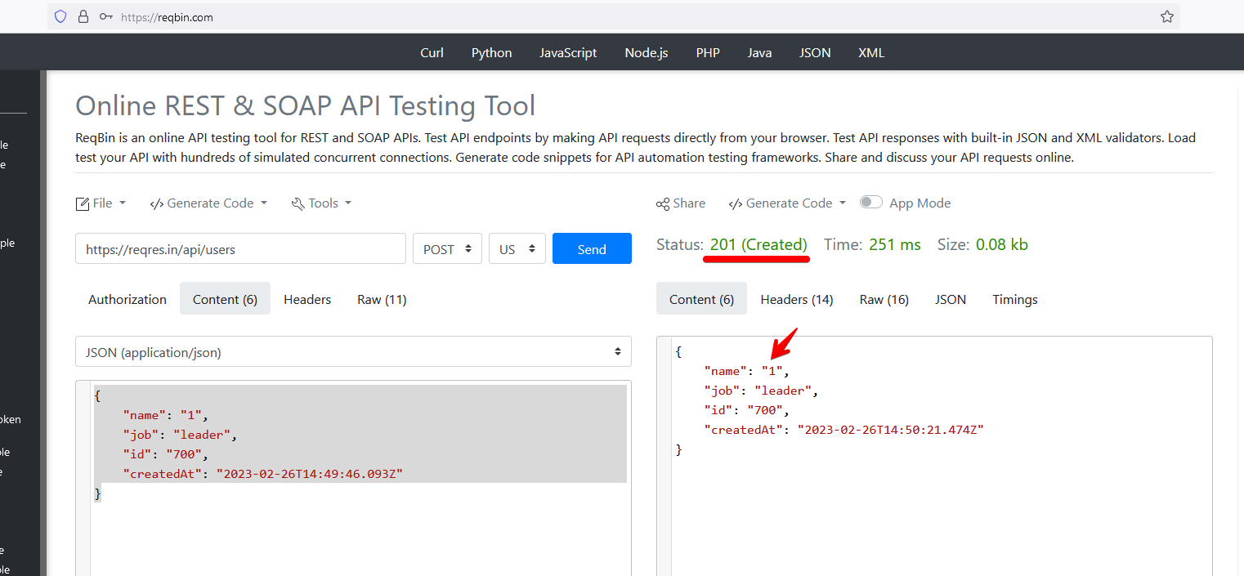

**—**

**Bug 2**

Title:

Using the POST API method it's possible to set the link in the name

**STR:**

1 Achieve the results from the previous "Bug 1"

2 Select POST method

3 In the body -> name -> instead of "1" add the link https://reqbin.com/

4 Press Send and check the results

AR: the system updates the name by setting the link

ER: It should not be possible to set the link in the name

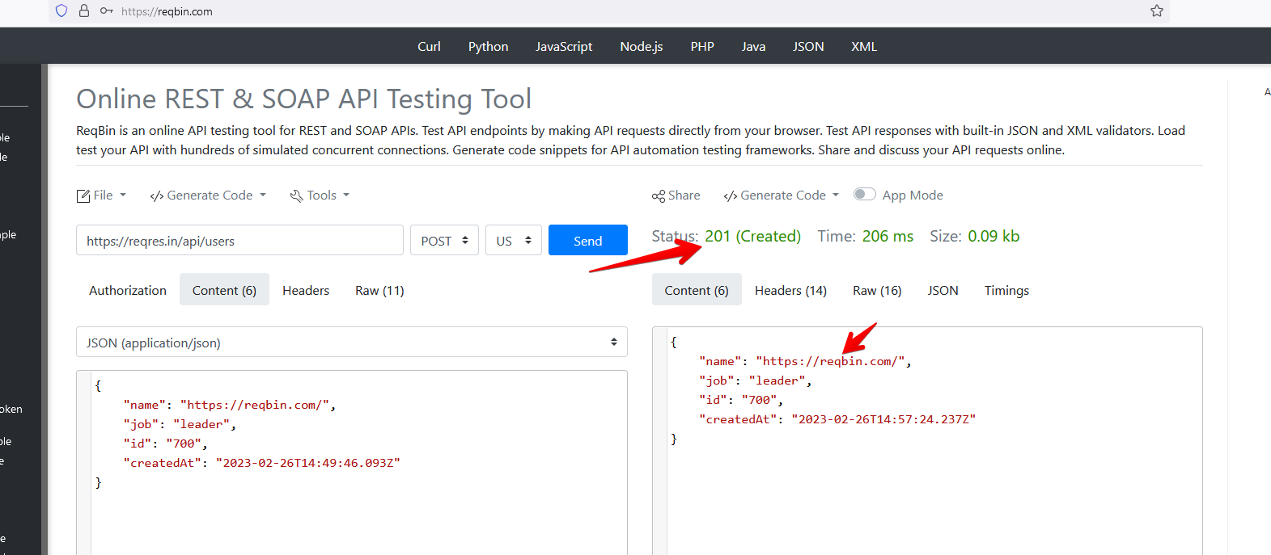

Title:

The system displays successful login even if incorrect password was used

**STR:**

1 Enter the following endpoint url https://reqres.in/api/login

2 Select the POST api method

3 Add the following content in the body:

{

"email": "eve.holt@reqres.in",

"password": "1"

}

4 Press send and check the results

AR: The system provides token and displays status 200 (OK)

ER: The system should display an error as the incorrect password was used

"email": "eve.holt@reqres.in",

"password": "cityslicka"

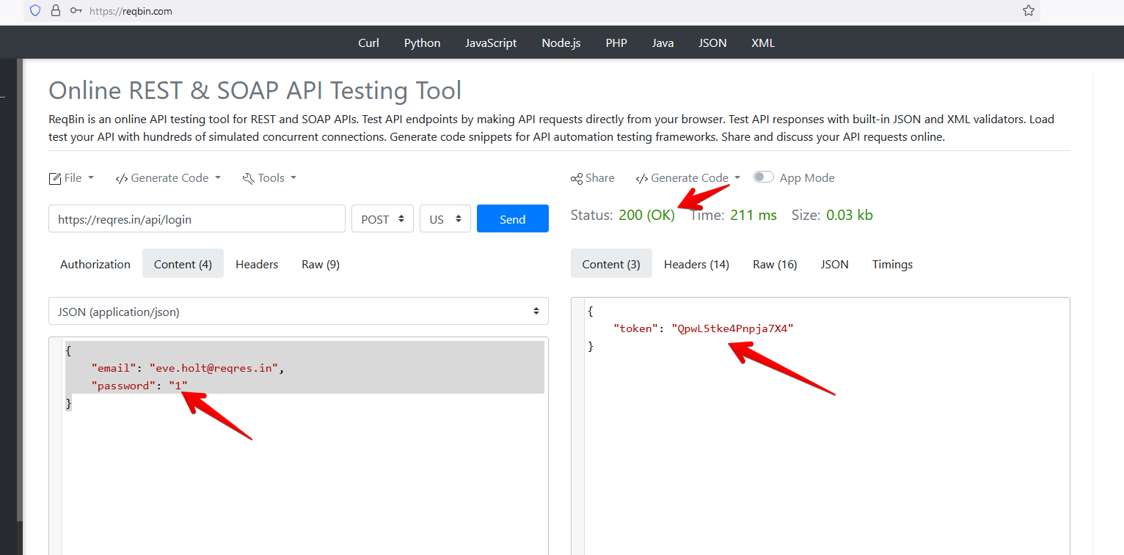

**Рівень 2-3**

**POST /public/v2/users**

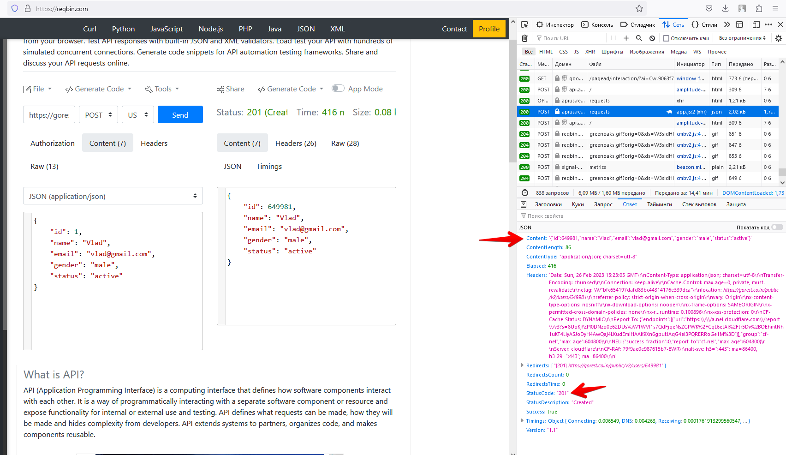

**GET /public/v2/users/978**

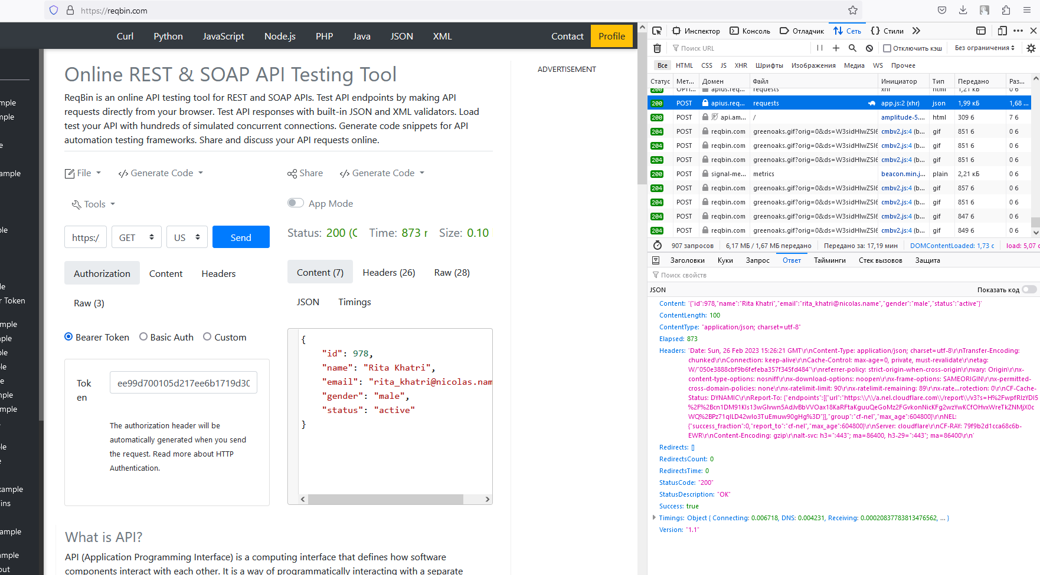

**PUT|PATCH /public/v2/users/978**

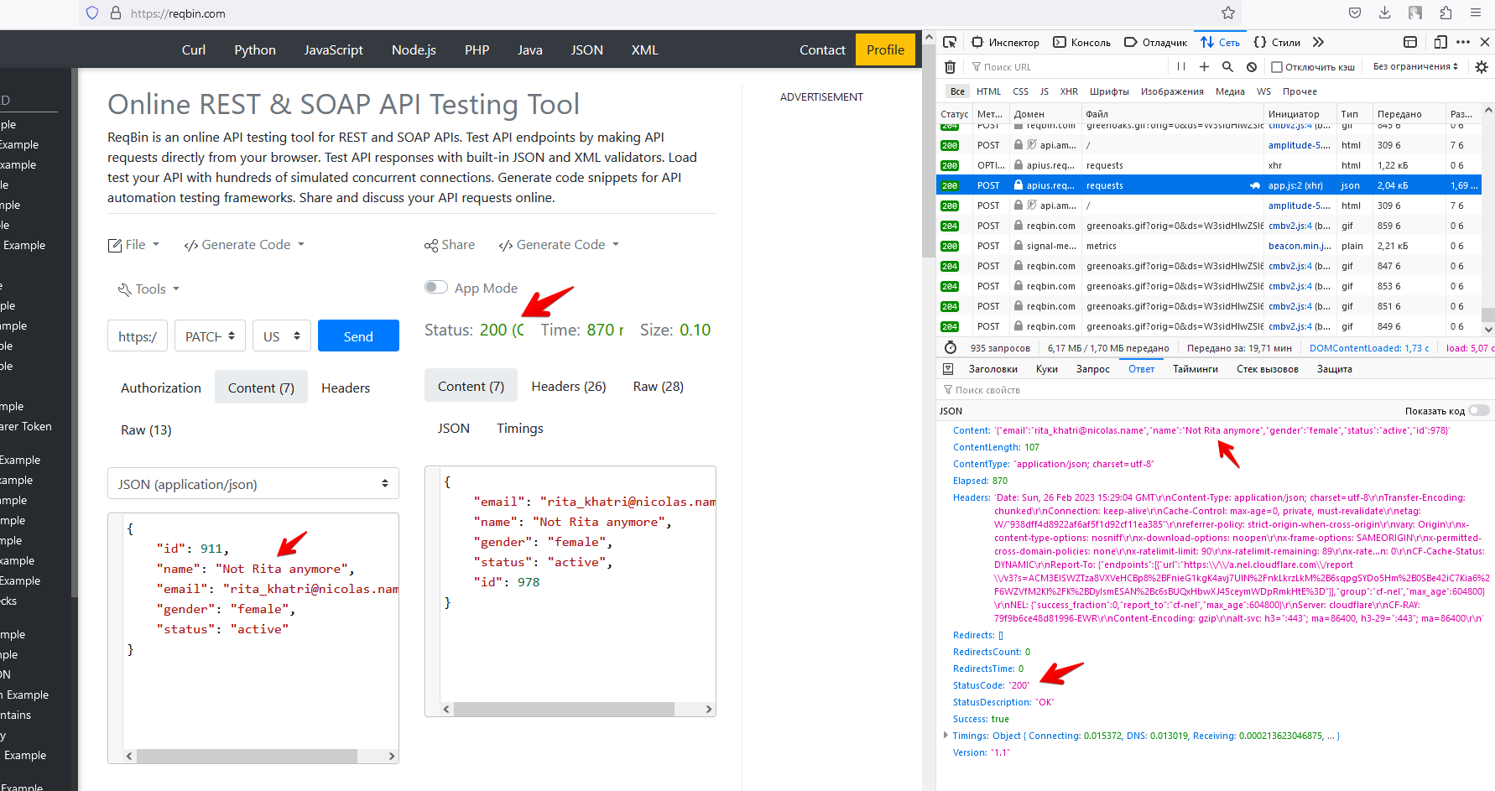

**DELETE /public/v2/users/978**

